

SRS 2



Hostel Management System



Software Requirements Specification (SRS)

Title: Hostel Management System (HMS)





Version Detail: First version



Page 1 of 19

Assignment # 4



Topic: Hostel Management System

Submitted to:

Sir Muzaffar Hameed Class BS (IT) 4

th

Session 2$$7—2$11

Department of Computer Science) B*+*University)

Mutan*

Submitted by:

SRS 2

SRS 2 inclu$es the following mem&ers

|  |  |
| --- | --- |
| Name | Roll * |
| Muhamma$ A)mal | 07-12 |
| Shah Rukh | 07-22 |
| Shah&a/ Malik | 07-26 |
| Qu$sia Zafar | 07-35 |
| Muhamma$ Faisal | 07-49 |

An$ a stu$ent who is not stu$ying this su&)ect with us &ecause of fails in a previous su&)ect.

His name an$ roll * is

Name Roll *

Danish Hussain 07-09

Table of Contents

Page # Contributors…………………….. 3

Statement……………………….. 6

Introduction…………………….. 7

* 1. Project overview…………… 8
  2. Project statement…………… 8
  3. Business requirements……... 8
     1. Descriptions……………… 8
     2. Objectives………………… 8
     3. Process flow……………… 9

1.3 Definitions &

Abbreviations………… 10

1.4 References…………………... 10

* 1. Product Descriptions………... 11
  2. General Business

Rules & Constraints………... 11

* 1. General Assumptions……….. 11
  2. Risk Assessment…………….. 12
  3. Detailed Requirements……… 13
  4. Functional Requirements…… 14
  5. Non-functional

Requirements………….. 15

* 1. Developing

Dataflow Diagram………….. 16

* 1. Symbols used in DFD……… 16

5.3 DFD of

Registrations in Hotel888.. 18

5.5 DFD of

Mess in Hostel888888 19





Intro$uction

This system is $esigne$ in favor of the hostel management which helps them to save the recor$s of the stu$ents a&out their rooms an$ other things. It helps them from the manual work from which it is very $ifficult to fin$ the recor$ of the stu$ents an$ the mess &ills of the stu$ents? an$ the information of a&out the those ones who ha$ left the hostel three years &efore.

@e $esign this system on the request of the hostel management? through this they cannot require so efficient person to han$le an$ calculate the things.

This system automatically calculates all the &ills an$ issue$ the notifications for those stu$ents who are against some rules.



# Project overview

# Project statement

The hostel management needs to create the hostel management system (HMS) to organize the rooms, mess, students record and the other information about the students. how many students can live in a room, and the students of the hostel can be recognized from their ID card number.

# Business Requirements

# Descriptions

This software product the hostel management to improve their services for all the students of the hostel. This also reduce the manual work of the persons in admin penal and the bundle of registers that were search when to find the information of a previous student, because through this system you can store the data of those students who had leaved the hostel three years ago. Through this you can check the personal profile of all the current students within few minutes the data base of the system will help you to check a particular one. You can select the time of the student to use the internet by allocating the specific time to every student. The system will help you to check the mess bills of every student and the student's hostel dues. The students of the hostel will be recognized from the ID number allocated at the room rental time. This system also attach to the system of the library and the departments, so that t5hey can access the data of the particular student. In the last this system will improve the management work in the hostel.

# Objectives



Stake Holder

Objective

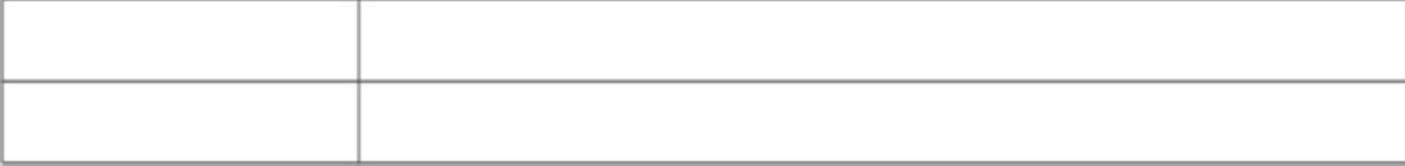

Student

The student can store his or her information

Administrative

The warden can see the data of students

# Process flow

There are four types of flow

### Registration flow

To take the membership of the hostel the students should tell the department's name to the hostel management system. He/she should fill his/her personal profile on the profile page. After this the warden issued ID # to him/her. So that the student can accessed bye his/her ID # in case of any problem or other thing.

### Mess Flow

When a student will use the mess his/her ID card will be scand by the system user at mess. A student can take only 2 messes at a time.

At the end of the month the hard copy of mess details issued to the student's room, which shows the detailed of his/her messes and all the dues of the mess

The student should pay the dues within 10 days after the issued of mess bill. In case of not paying dues the warning letter is issued against the student.

### Room process flow

A room will be allocated when a student is registered in the hostel. The allocation will be on the basis of the department, semester and the session of the student. A room is only for the two students.

The dues of the hostel is only for 1 semester and after the end of the semester the student should pay the next semester's dues. The student will pay the dues within 10 days after next semester.

In case of not paying the dues of the hostel at the announced date a warning is send to the student.

In case of the unavaila&ility of a room the stu$ents will &e entere$ in a waiting list when the room will &e free the stu$ent will &e tol$ &y the management of the hostel.

### Database flo1

When the new student is arrived then the administrator easily enter a new entry in the database of the system. All the information about mess and other facilities is updated easily. This database should save the record of all the current users and the 3 years old students.

## 1*4 Definitions 7 Abbreviations

HMS Hotel management system

User The student who lived in the hostel.

Administrator The warden of the hostel who manage all the things.

ID card The card issued bye the hotel which contains the information of the student.

Database the records of every current and old students is saved here.

Account number The issued bye the HMS when the new students becomes

the part of the hostel. This number is on the ID card of the student. This is user's ID.

Mess status it tells the mess information of the students.

User8s profile It contain the student's personal information. e.g.. his

name, father's name, his full address etc.

# 1*5 References

[1].DFD link from <http://nptel.iitm.ac.in/courses/Webcourse-contents/IISc->

BANG/System%20Analysis%20and%20Design/pdf/Lecture_Notes/LNm5.pdf [2].SRS material link from <http://www.kassoftindia.com/Product/GeniusAcademic/hostelmgt.htm>

We take the material from the sites and follow the pattern you have given in the example.

# 2*1 Product descriptions

2*2 General Business Rules 7 Constraints

The system is desired to handle all the activities of the students as well as the administrative level. The system will have the ability to search the student's information about his/her room mess and all the other things. Once the current and previous record is entered then the database will be updated for the new students automatically.

This system is for hostel so that the primary users of the system are the students and the administrative penal.

The main constraint is the system registration is valid if the department has been approve that student is valid for the department.

The constrains are the amount of the hostel dues and the mess dues that are calculated in the system. These dues should be paid within 10 days. If anyone could not do the payment for some reason the system will notify the name of the student.

* System will uses warden of the hostel.
* The Hostel id card is necessary to use mess.
* Barcode is used to read the id of the student.
* Time constraint

# 2*2 General Assumptions

The following details any high level assumptions regarding the proposed changes including any restrictions regarding scope of the project. It also details any functionality limitations or environment or design limitation that may impact the design or delivery of the change. Details are also provided on any assumptions that may impact the requestor/customer/user.

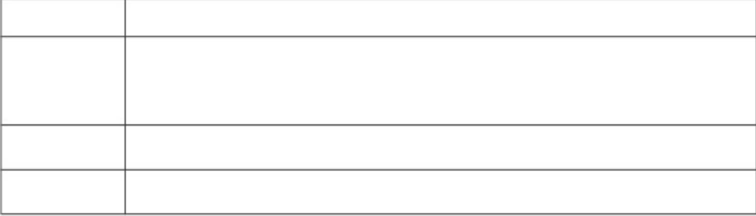

Area

Hostel processes

Descriptions

All other hostel relate$ functionality an$Cor processes will remain intact. The process an$ logic the system executes to manage the hostel user accounts will remain the same as the process &efore automation.

Data&ases The un$erlying $ata&ase to &e use$ for this system is alrea$y in place as part of

the stan$ar$ infrastructure.

A$ministrator <nly the war$en will a$minister the system. All other hostel employees will only have access permissions like any other users.

# 2*4 Ris5 Assessment*

This section provi$es a risk assessment for each assumption or constraint. Also containe$ in this section is the analysis of the impact an$ pre$iction of the response inclu$ing quantification? where possi&le.

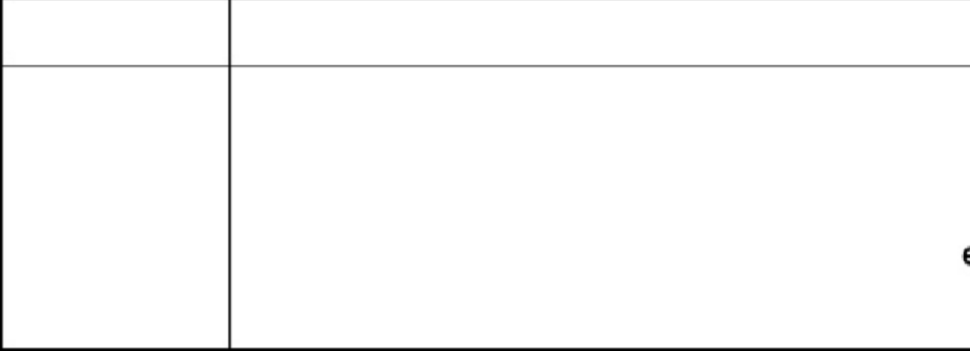Descriptions Area

The system automates many of the current maAncucael **p**traon**ce**ss. This may render some of the hostel emp

To mitigate this, adequate communication will b benefits to be derived from the system.

# 2*1 Detailed Re3uirements

## 2*2 Functional Re3uirements

Registration

SRS001 Add Users

The Hostel Management System shall allow the warden to add new users to the system's database.

SRS002 ID card

The HMS shall generate an account number. This number will be the user's ID number.

SRS003 User8s Profile

The HMS shall generate the user's profile containing the following information: user's account number, user's full name, user's address, user's phone number, user's room # and mess account #.

SRS004 Room Allocation

The HMS will allocate a room to student according to the session or class.

The room no. will store in the student's profile.

SRS005 Mess A;C

A mess account will also generate. This account having the mess status of the whole month. On the base of this account monthly charges of mess of a student will be defined.

SRS006 User8s Profile

Profile of each user will be created before operating HMS including guardian to maximize the HMS security.

SRS007 Student8s Profile

The HMS shall allow the hostel staff members or guardian to scan the student's ID and access its profile. Student dues status and mass A/C status can be accessed here.

SRS008 Dues Status

Student dues status will be changed in database according to dues pay or not.

SRS009 Mess Status

HMS will also having the $etail of mess of a stu$ent an$ store$ in

$ata&ase.

SRS0010 Room Reservation

The HMS will allow staff to put a hold on a room if any room is not available at the moment.

Database

SRS011 Database <ntities

The HMS has entities users, students, room, mess A/C.

SRS012 The HMS will have in the room profile the following information: room no, type and capacity.

SRS013 Student Search

The HMS shall allow the users to search the students from the database according to different criteria such as by name, id or phone number.

SRS014 User Search

The HMS shall allow the users to search the user from the database according to different criteria such as by name, id or phone number.

SRS015 Profile8s Update

The HMS will allow the guardian to access and update any student's, room, and HMS user's profile information.

SRS0116 Room at leaving

When a student will leave its room. Room will checkout and changes the status of room from room profile and student's registration will be cancelled.

Registration Options

SRS017 Room Rene1al

The HMS will allow renewing the student's registration every year.

SRS018 Cancel Registration

The HMS will allow the guardian to cancel registration from the system's database who will leave room.

# 2*2 Non>functional Re3uirements

SRS019 Performance

The system shall support up to 2 students per room.

SRS020 ID scanning

The system requires the user to identify by using an ID card at the checkout point.

SRS021 Access Permission

The HMS shall have several types of access permissions. For instance, the warden is recognized as the system's administrator, thus, the warden shall be able to perform any type of activities on the system and both the user's and student profiles. At the same time, the other hostel staff members shall have restricted access to both the users' and student profiles. The public in general shall be restricted from accessing any user profile. However, they shall be granted a read access on the student profile.

SRS022 Maintainability

The system shall provide the capability to backup the database.

SRS023 Reliability

The system shall be available 99.9% of the time.

SRS024 Other constrains

The system shall support barcode scanning of ID cards and hostel issues.

SRS025 The HMS shall be flexible and adaptable due to future plans of expanding the system.

# Developing Data Flow Diagrams (DFD) Of Hostel Management system

# SYMBOLS USED IN DFD

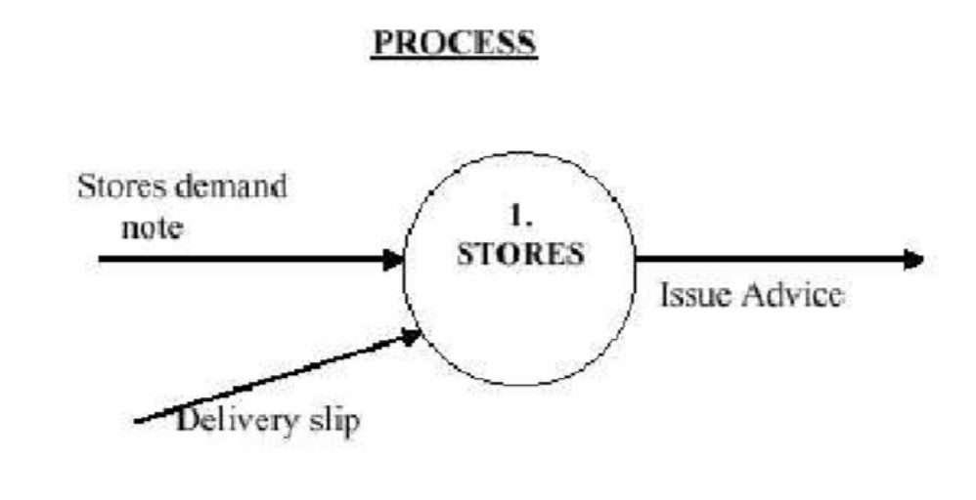

A circle represents a process

Straight lines with incoming arrows are input $ata flows Straight lines with outgoing arrows are output $ata flows Processes are given serial num&ers for easy reference La&els are assigne$ to Data flow. These ai$ $ocumentation

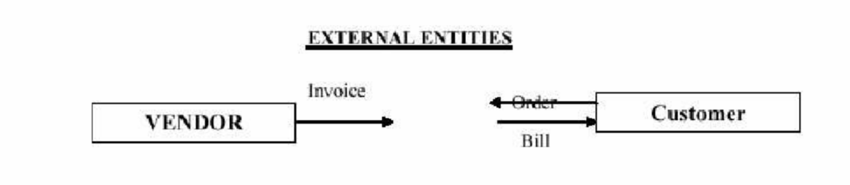

A Rectangle represents an external entity . They either supply $ata or receive

$ata. They $o not process $ata

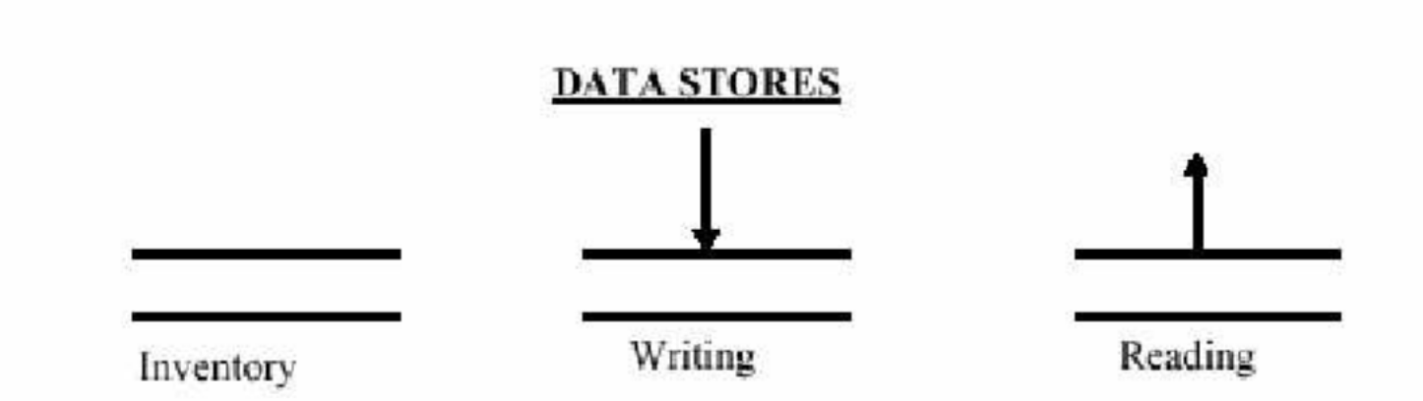

A Data Store is a repository of $ata

Data can &e written into the $ata store an$ this is $epicte$ &y an incoming arrow.

Data can &e rea$ from a $ata store an$ this is $epicte$ &y an outgoing arrow Jxternal entity cannot rea$ or write to the $ata store. Two $ata stores cannot &e connecte$ &y a $ata flow

RKLJS <F DATA FL<@

LData can flow from

-external entity to process

-process to external entity

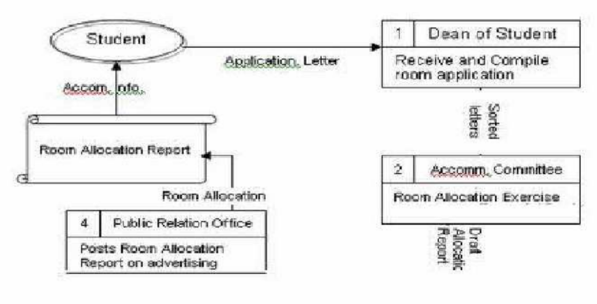4*2 DFD of Registration in Hostel

4*4 DFD of Mess in Hostel

